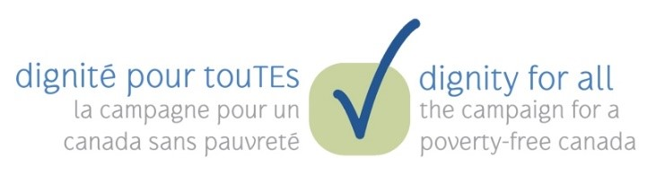
Your Name
123 Your Street
Your City, ST 12345
(123) 456-7890
no_reply@example.com
[date] October 2021
The Honourable [MP First & Last Name]
CEO, Company Name
123 Address St
Anytown, ST 12345

Dear Ms./Mr. [last name],
Congratulations on your recent success in the federal election. As your constituents, we look forward to working with you to build a more just and sustainable society.
October 17 is the International Day for the Eradication of Poverty. Every year, the Chew on This! campaign marks this day by calling on the Government of Canada to honour our international human rights obligations and commitments to the Sustainable Development Goals by working towards the eradication of poverty in Canada.
We firmly believe that poverty is a violation of each person’s inherent rights and dignity. We also recognize that poverty is caused and perpetuated by inequities in our systems, and disproportionately impacts people who are Indigenous, Black, disabled, 2SLGBTQQIA+, women or gender non-conforming, single, or who have precarious immigration status.
In 2018, the Government of Canada committed to reducing poverty by 50% of 2015 levels by the year 2030. We want to know who will be included in that 50%? Who will be excluded? We would also like to bring to your attention the fact that measures of low-income alone do not adequately capture the incidence or experiences of poverty in Canada. Food security, core housing need, and access to necessary medical and social services are also critical benchmarks.
We will not end poverty without ending inequity. Canada needs a rights-based, comprehensive plan to eradicate, not just reduce, poverty, with specific targets and timelines for equity-seeking groups. We ask that you sign the enclosed pledge to signal your commitment to ending poverty and inequity in Canada.
Sincerely,
[all signatures on separate lines, with organizational affiliation, if applicable]

Pledge: End Inequity, End Poverty
I, the undersigned, recognize that poverty is a violation of people’s inherent rights and dignity, and that the Government of Canada has a moral and legal obligation to honour its commitments to international human rights and the Sustainable Development Goals.
I recognize that poverty disproportionately affects certain communities because of systemic inequities in our systems and institutions. This includes people who are First Nations, Inuk, and Métis, Black, and People of Colour; women and gender diverse people; people who are disabled, 2SLGBTQQIA+, single, or who have precarious immigration status; and children, seniors, and youth who are aging out of care.
I pledge to work with Members of Parliament, Ministers, and Senators from all parties to adopt ambitious targets, timelines and budgets for poverty eradication among equity-seeking groups. To do this, I pledge to work with First Nations, Inuit, and Métis governments and organizations, as well as other equity-seeking groups and members of civil society to develop, implement, and monitor policies that are consistent with our human rights obligations and that are grounded in people’s lived experiences of poverty and other intersecting forms of systemic oppression.
Specifically, I pledge to support the legislation of the following targets, along with adequate federal investments and action plans:
- Ensure sustainable access to safe drinking water by 2023 and to adequate, culturally appropriate, nutritious food in the territories and on reserves by 2025. Eliminate food insecurity for all by 2030.
- Establish a minimum income floor for all people living in Canada, bringing them up to 60% of the median income of all Canadians by 2025.
- Eliminate core housing need and homelessness by 2030, tracking data to ensure equitable progress along the way. Close the gap in funding for rural vs urban housing and homelessness immediately.
- Eliminate unmet medical needs due to financial constraints by expanding Canada’s public health care system to include in-community, culturally appropriate access to publicly funded pharmacare, mental health, dental, vision, and physiotherapy by 2025.
- Ensure all families can access affordable, flexible, accessible, publicly funded, and culturally appropriate early learning education and child care, investing in the creation of additional subsidized spaces and fair compensation for staff by 2025.
- Close the gaps in employment rates and pay equity experienced by equity-seeking groups by 2030.

Signed, ____________________________________ Date: ________________________
Please print your name and title below.

___________________________________________________________________________

